Basic setup of the project.

**Created a my_thing in the IOT core. This is the IOT**

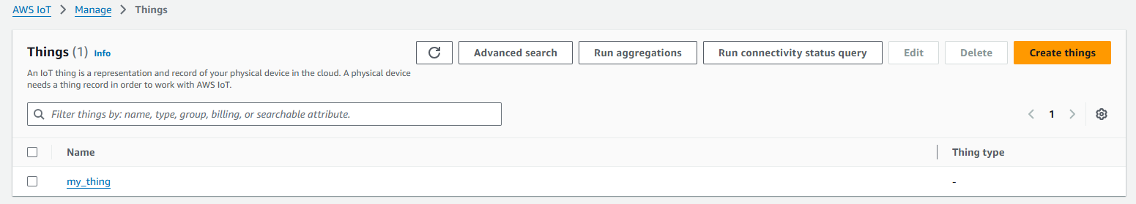

**Created a my_iot_rule to send emails, this is connected with the SNS.**

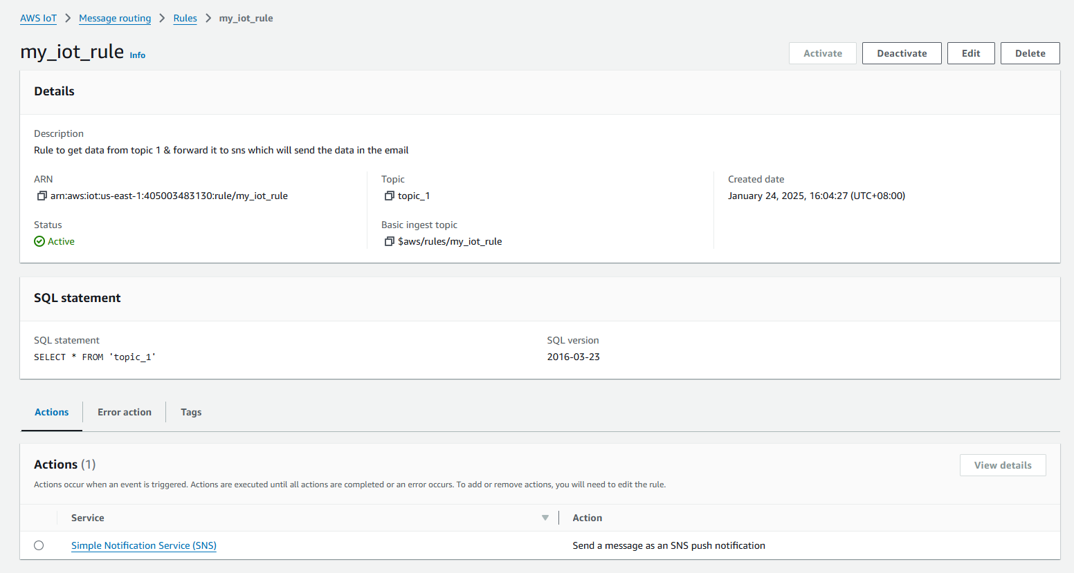

**Created another rule called my_iot_db_rule this is to store all the data into the dynamo db table.**

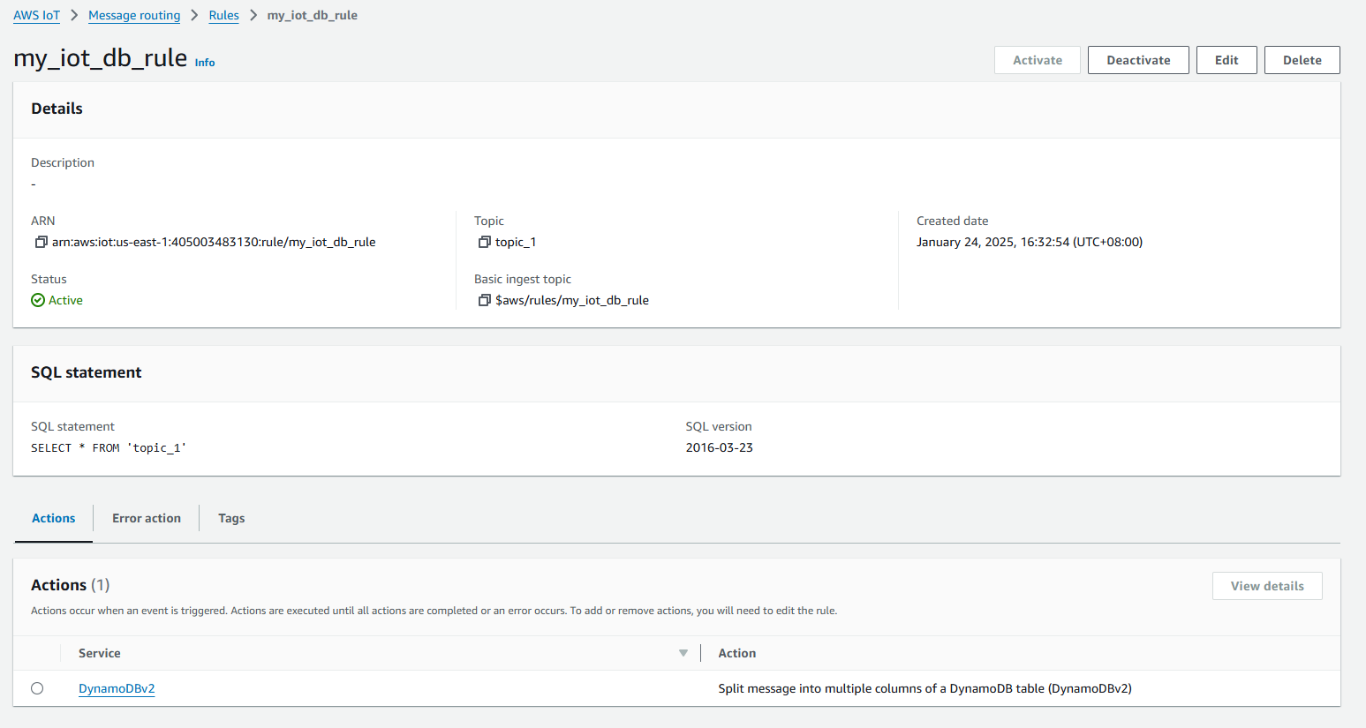

**Created another rule called my_iot_lambda_rule to trigger the lambda function for the backend processing.**

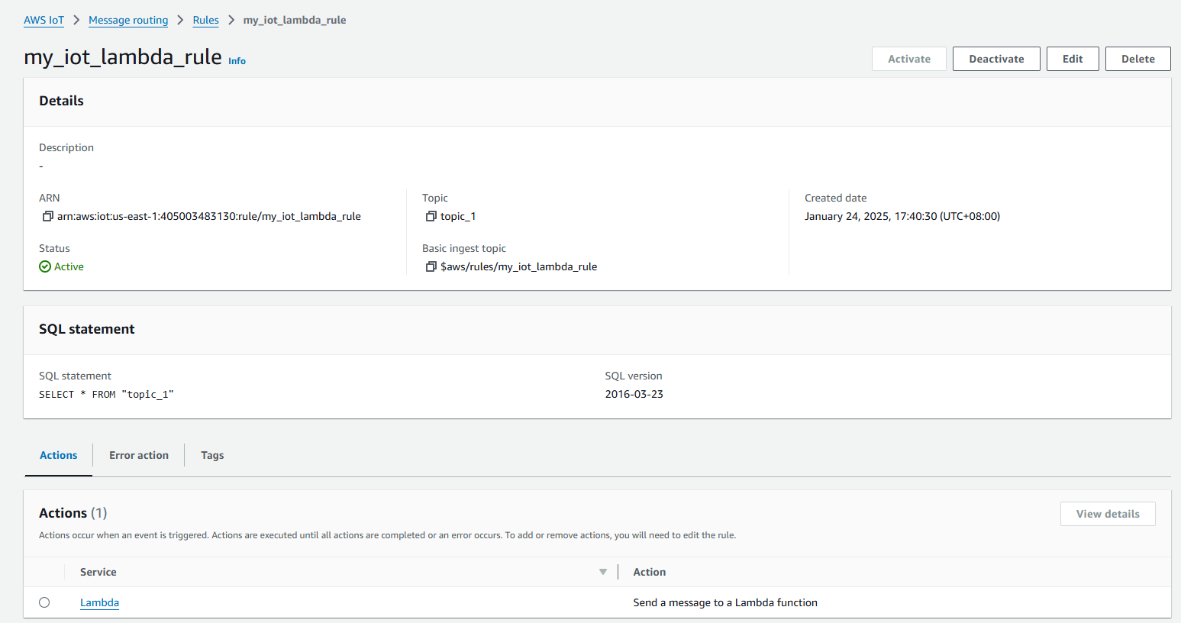

**I also created a dynamo db table**

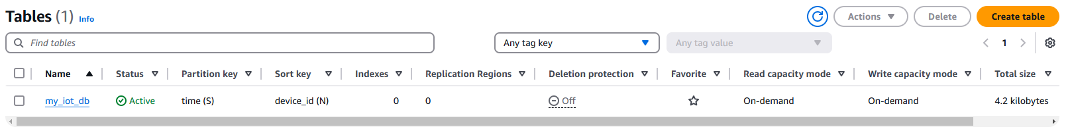

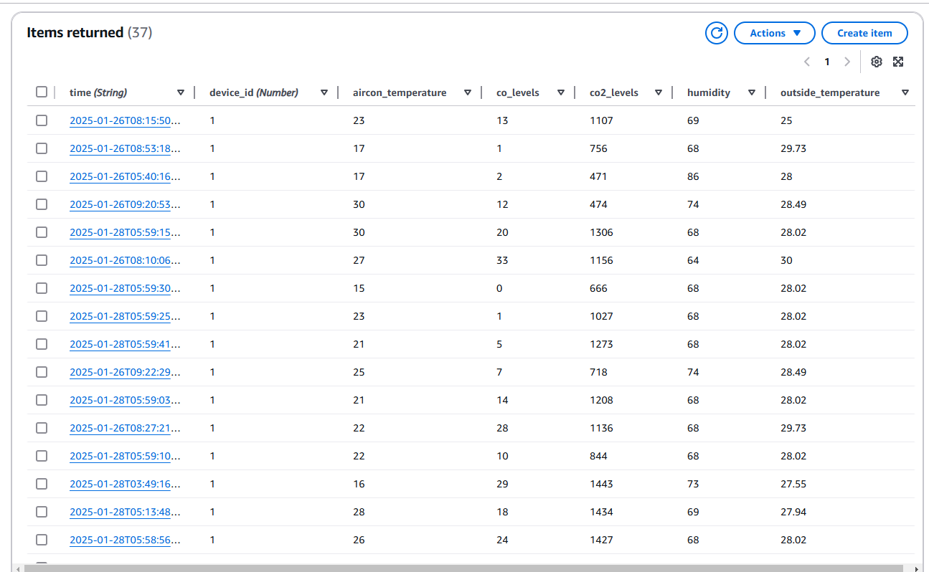

**This is the lambda function**

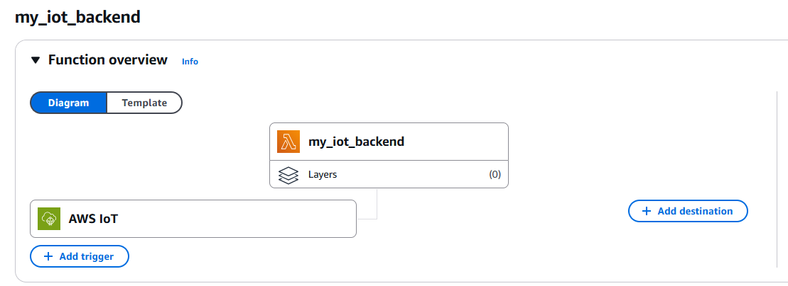

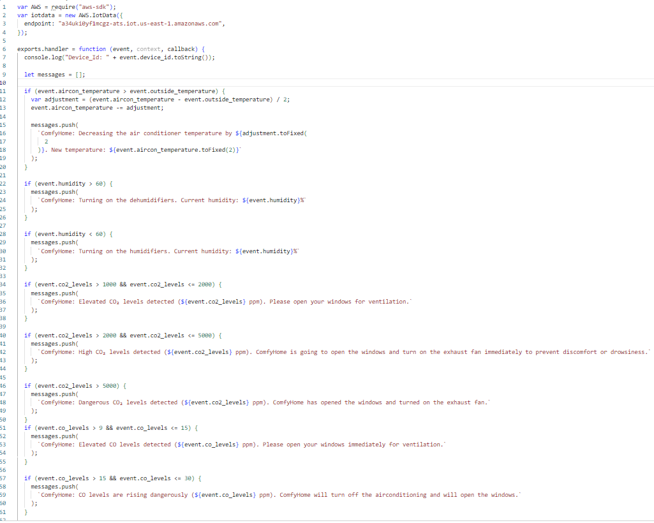

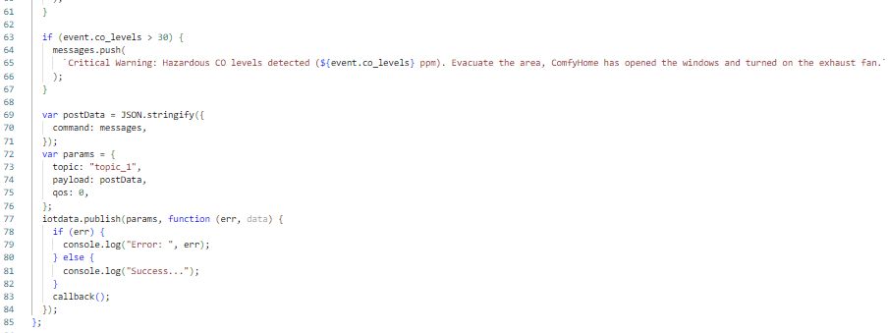

**This is the SNS**

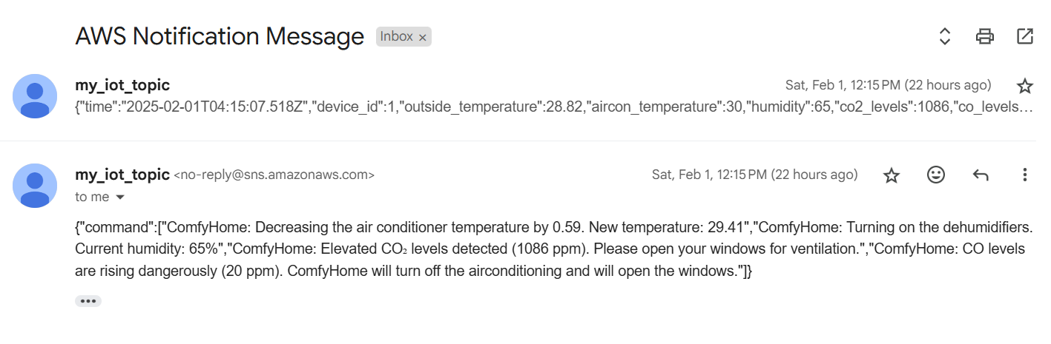

Additional features ITAD project

**Additional AWS lambda function**:

To get all the records stored in the dynamo db. I attached this function to the api gateway later.

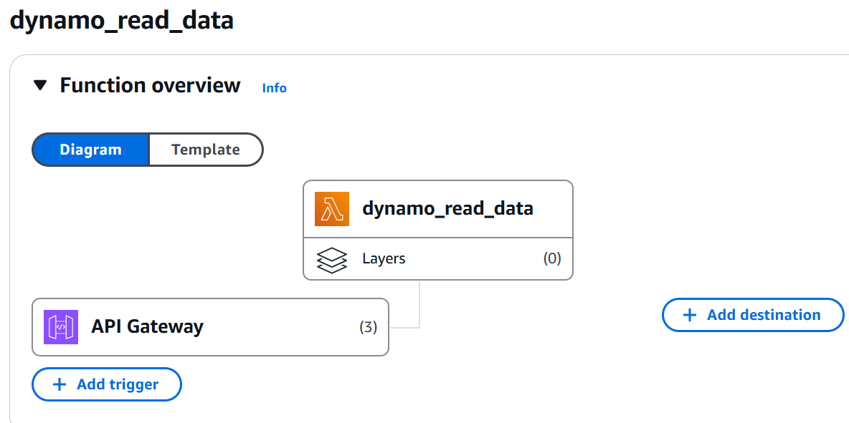

To get all the records from the dynamo dB using the scan method.

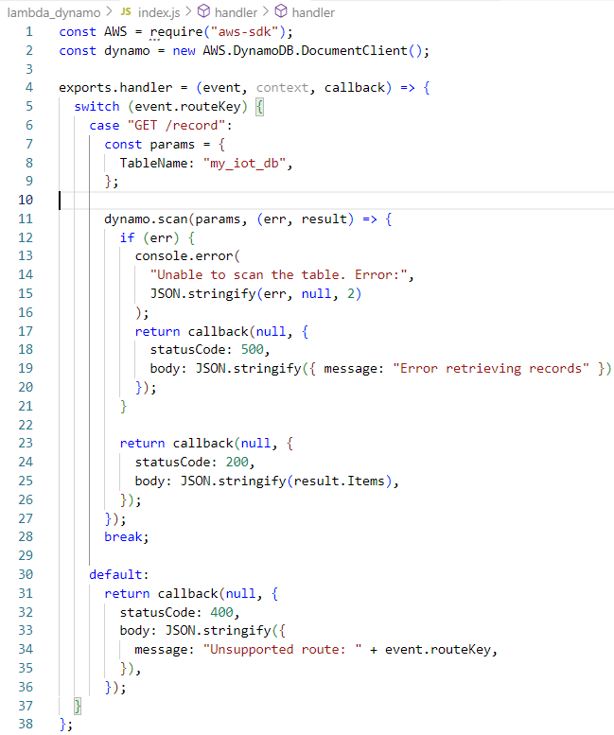

**AWS API gateway:**

I created an endpoint which I will be using later on for a website and I attached this api endpoint to the lambda function to retrieve all the data. I created an endpoint /record with the GET functionality. This api is authorized based on the JWT token, configurations made with aws cognito which I will show later on thus it uses JWT auth for authorizations.



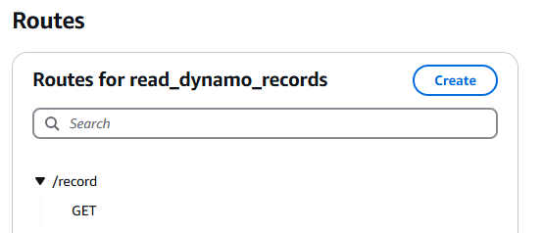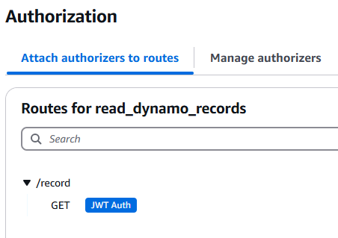

I then connected my api route to the lambda function to integrate the GET process.

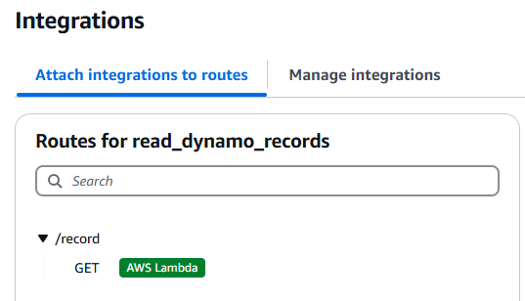

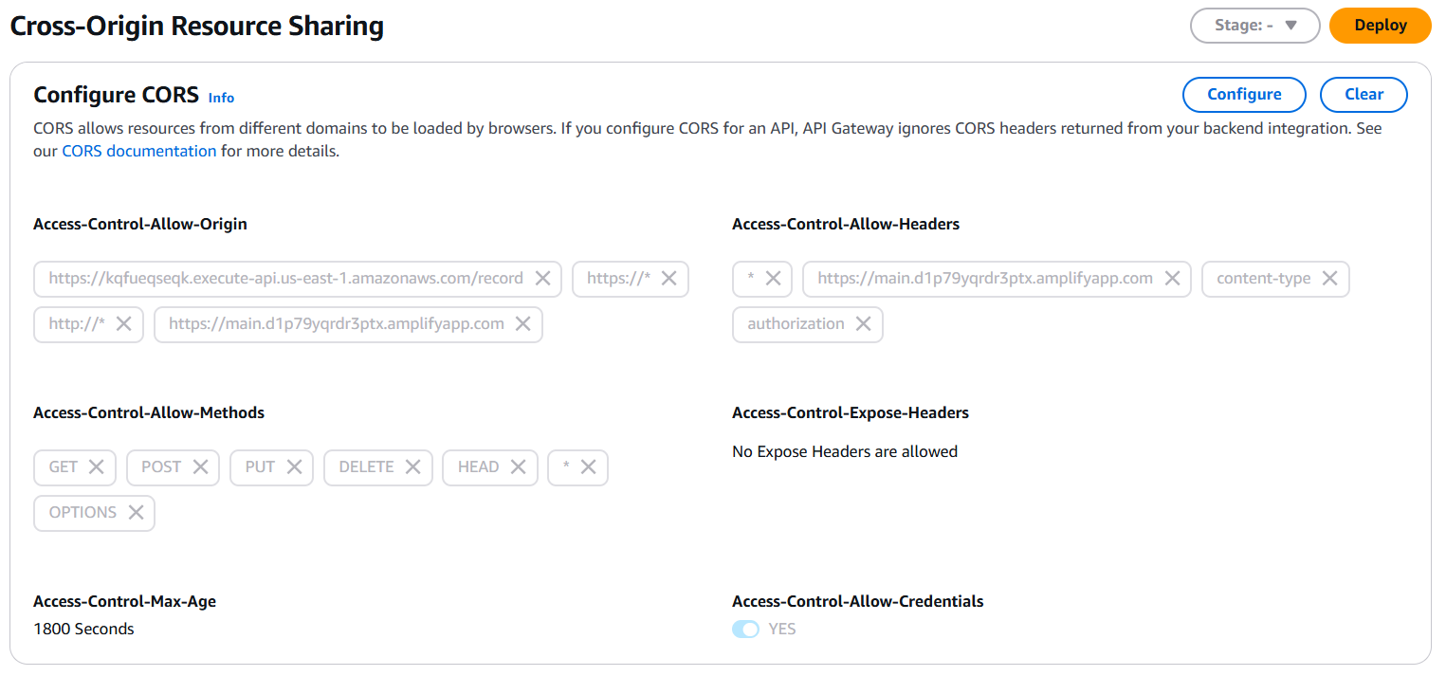

**AWS Amplify:**

I used this to host my application publicly. I have created frontend and backend codes to make this website using javascript css and html.

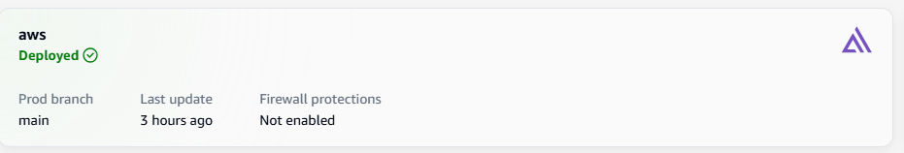

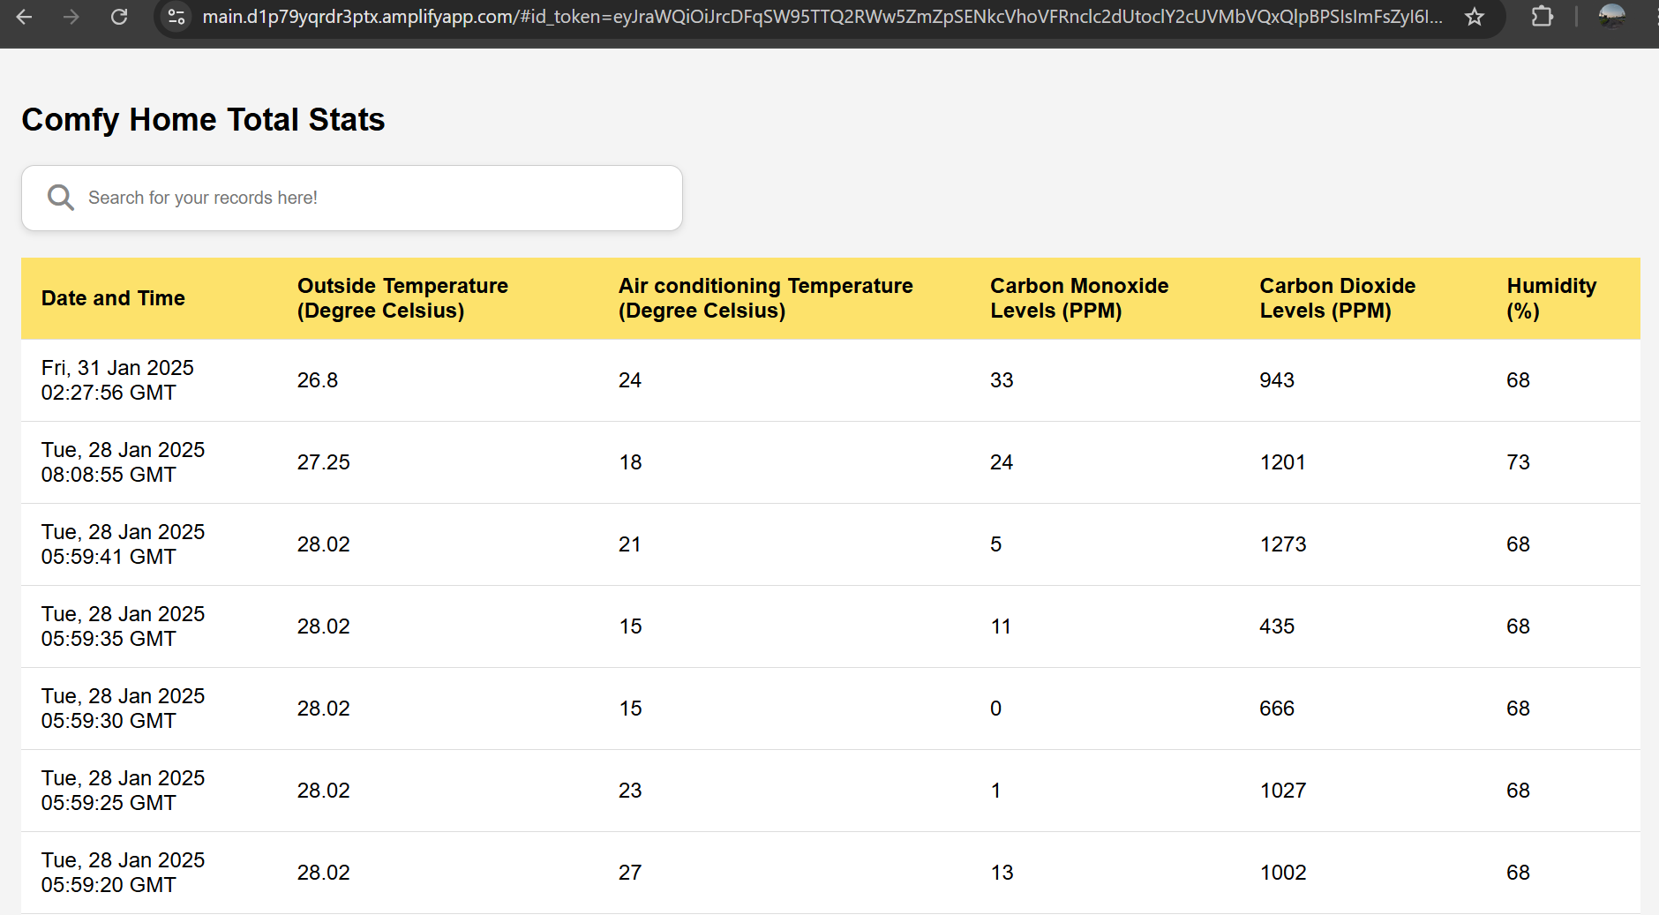

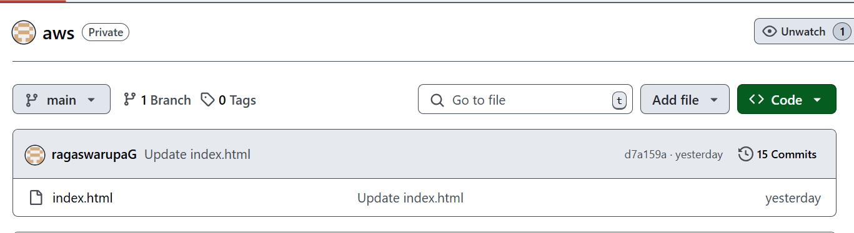

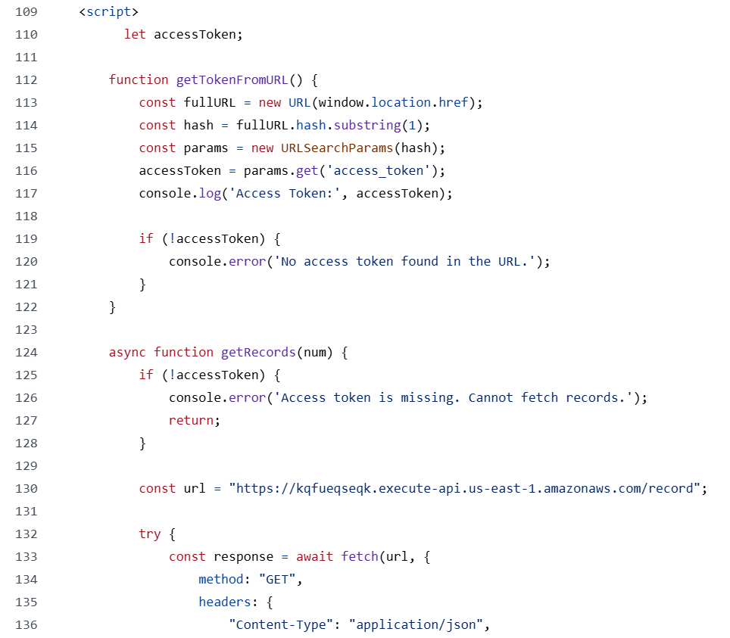

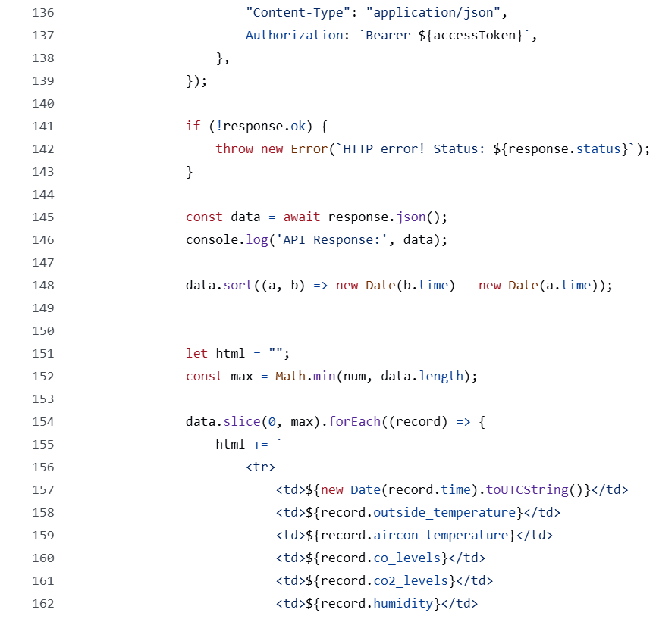

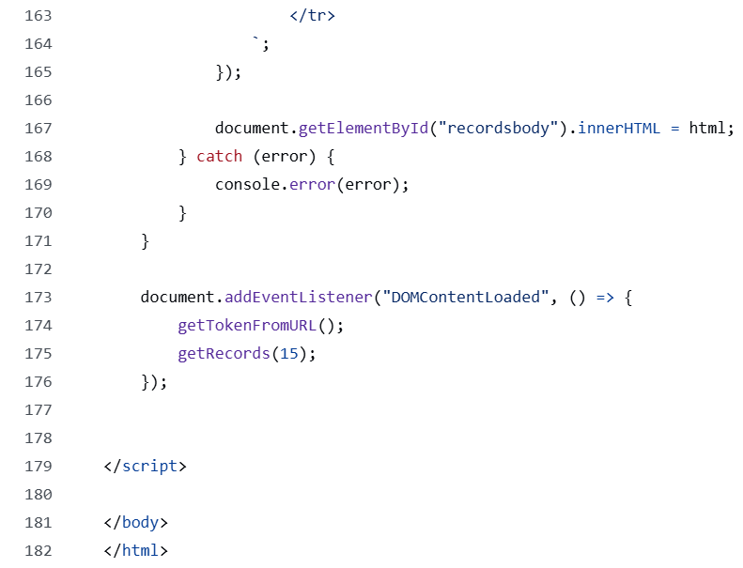

**Cognito:**

ensures that my application has features like logging in, signing up, forget password etc. It makes sure that only authenticated users can access this site. If logging in is successful, it assigns a JWT token and with this token only, it will be possible to access the records if not you cannot view them.

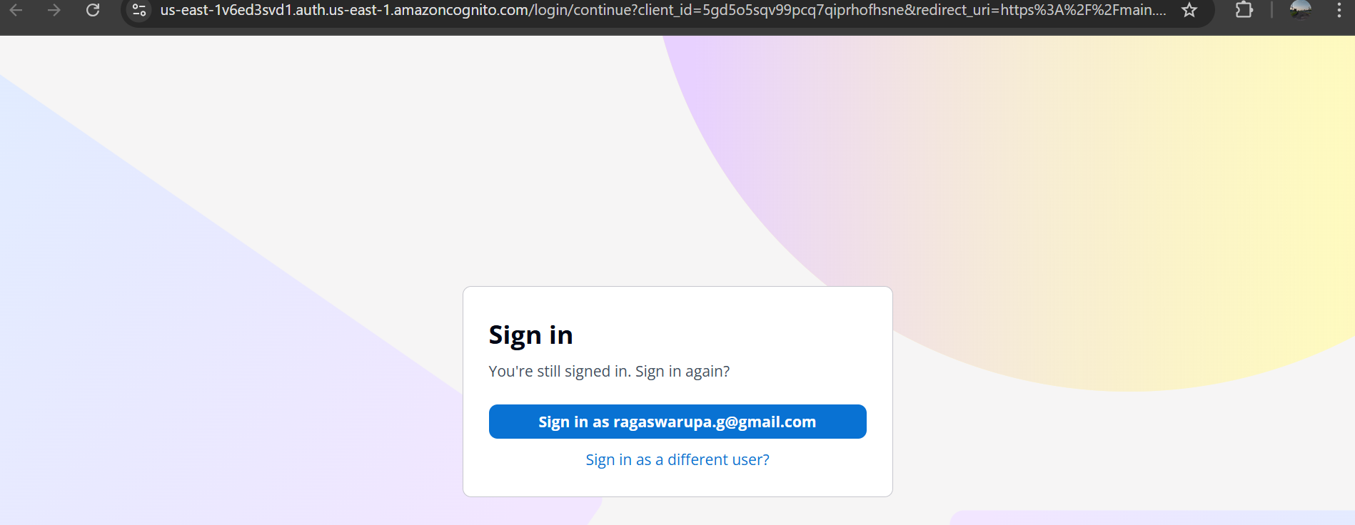

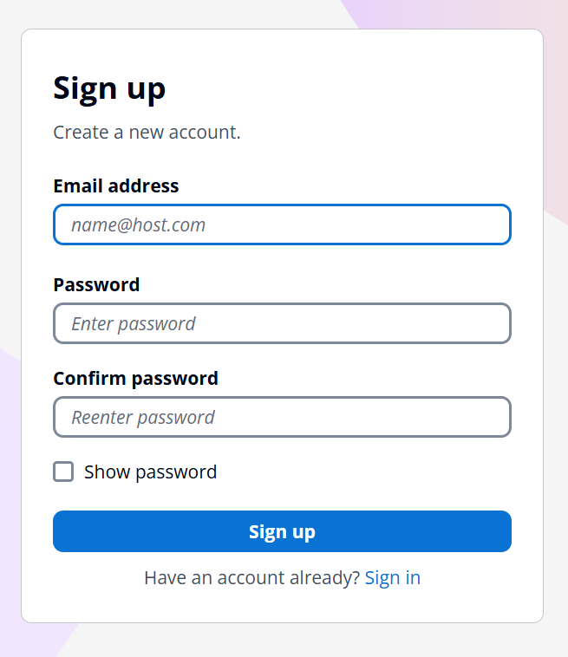

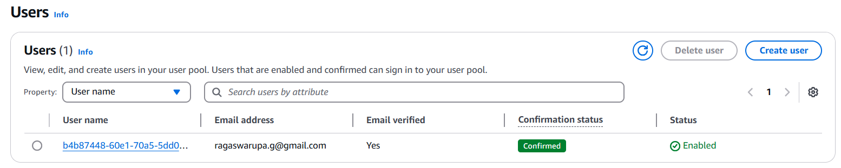

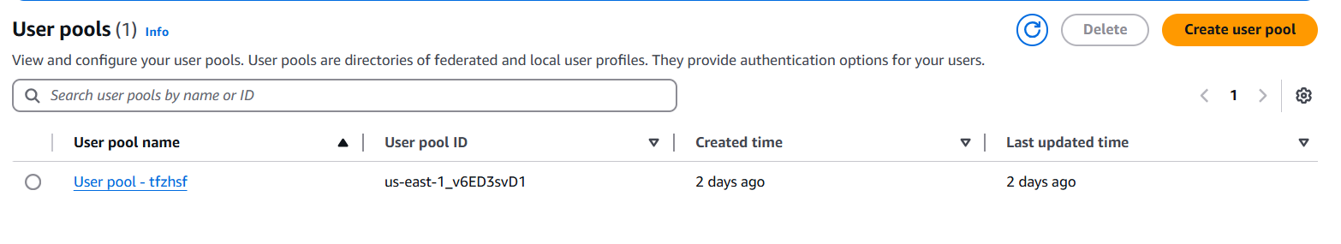

**CloudWatch:**

I used this service to monitor and view all the statistics of all the services I am using. I can also set alarms if something is wrong.

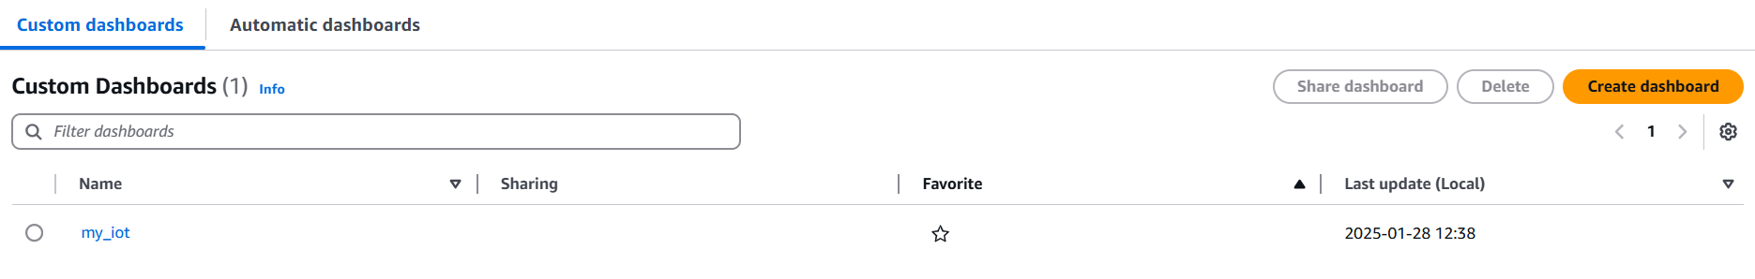

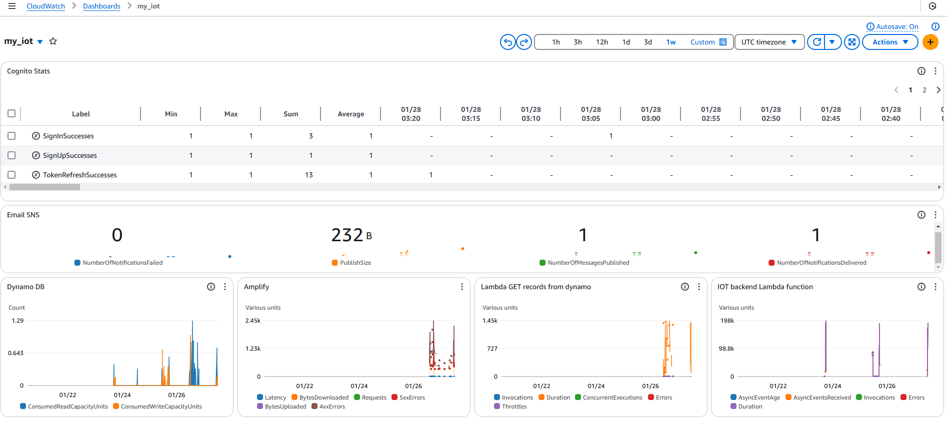

**AWS Budgets monitor:**

I can use this monitoring tool to ensure that my spending is normal and is within the budget. I can view anomalies and my total spending details here in this monitoring dashboard.

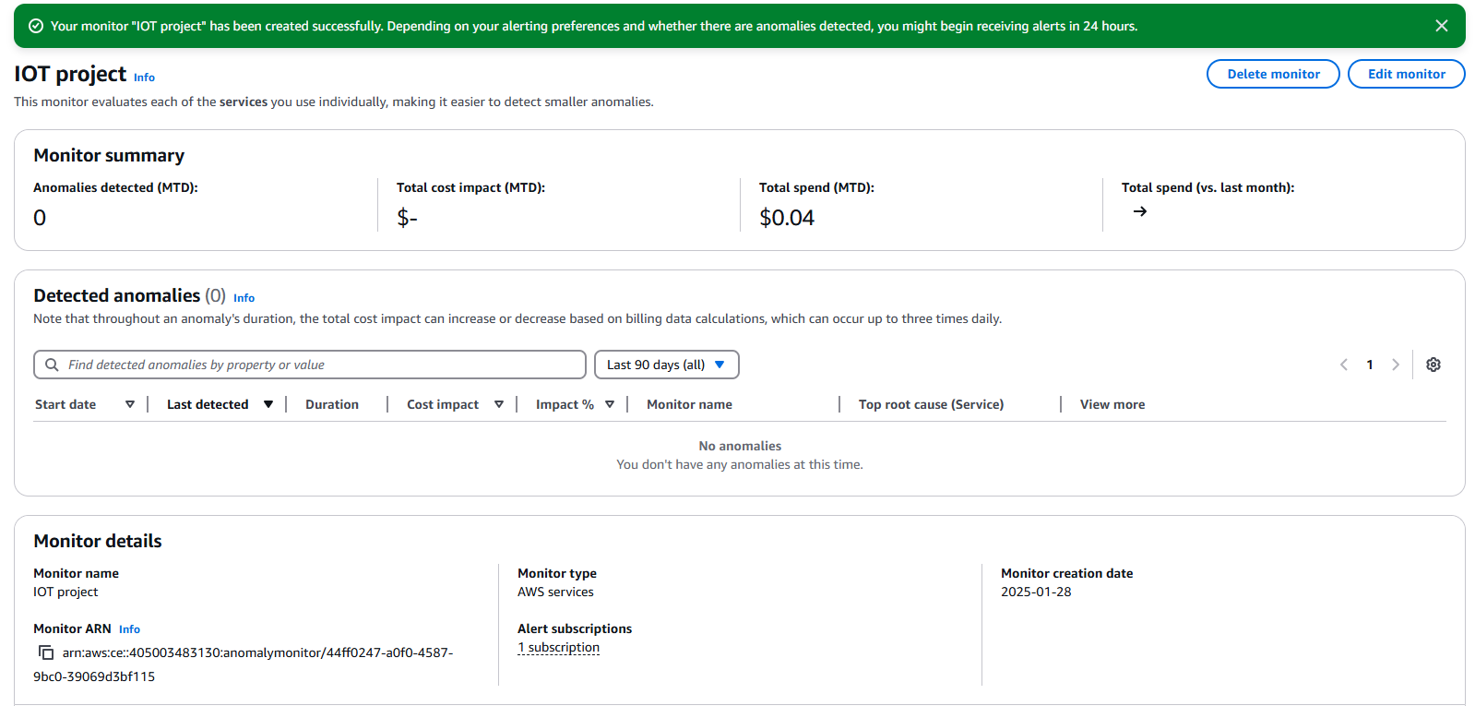

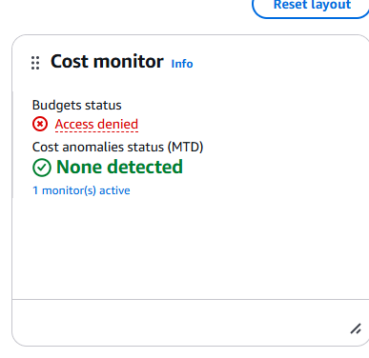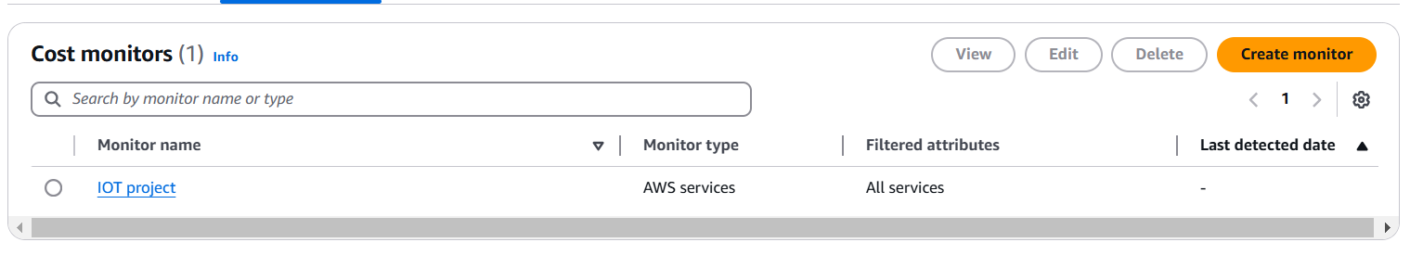

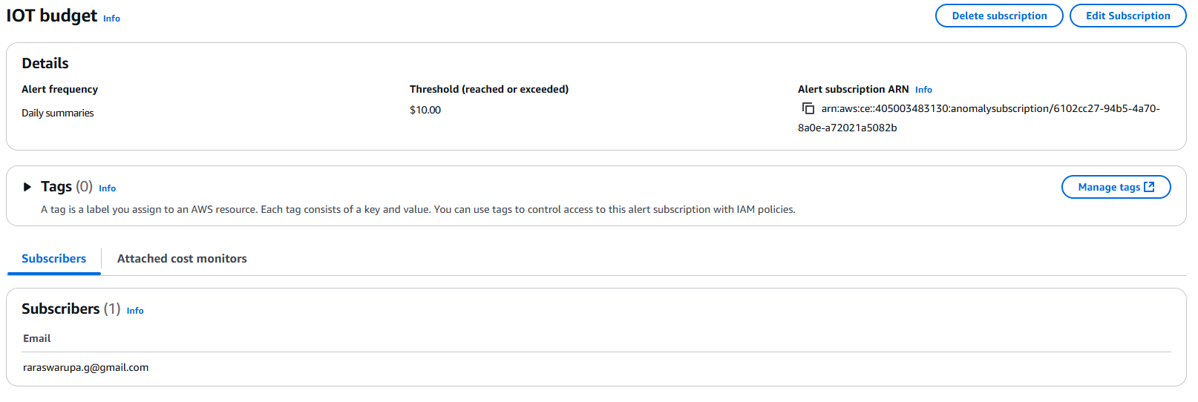

I can get an email if the budget exceeded or for other reasons.

**AWS Kinesis**

* I am using this feature to collect some metrics based on all the incoming data from the IOT device. Please refer to the video for the demonstration of this service.
* <https://youtu.be/M06VZUUGr8U>
* I implemented this feature using the shared student’s AWS portal to use some services which are restricted for the personal learner's lab given to us.

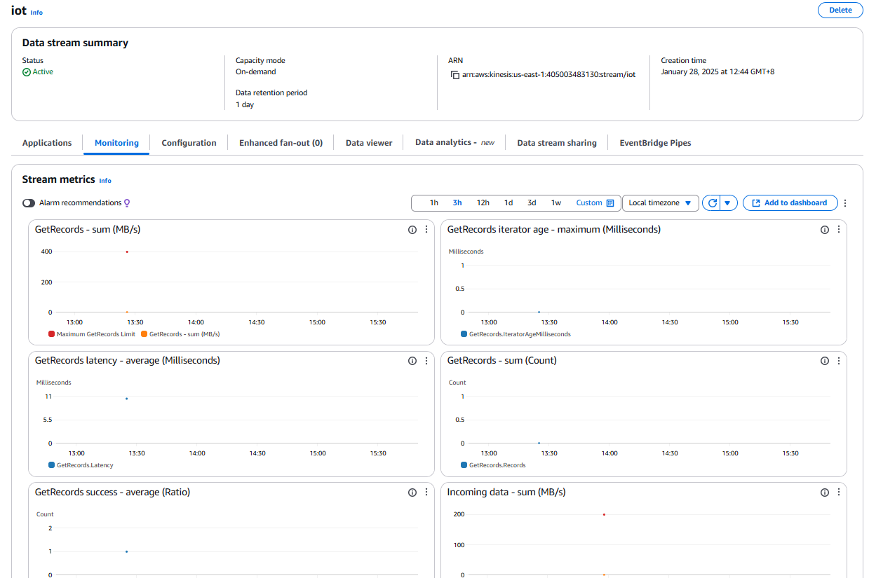

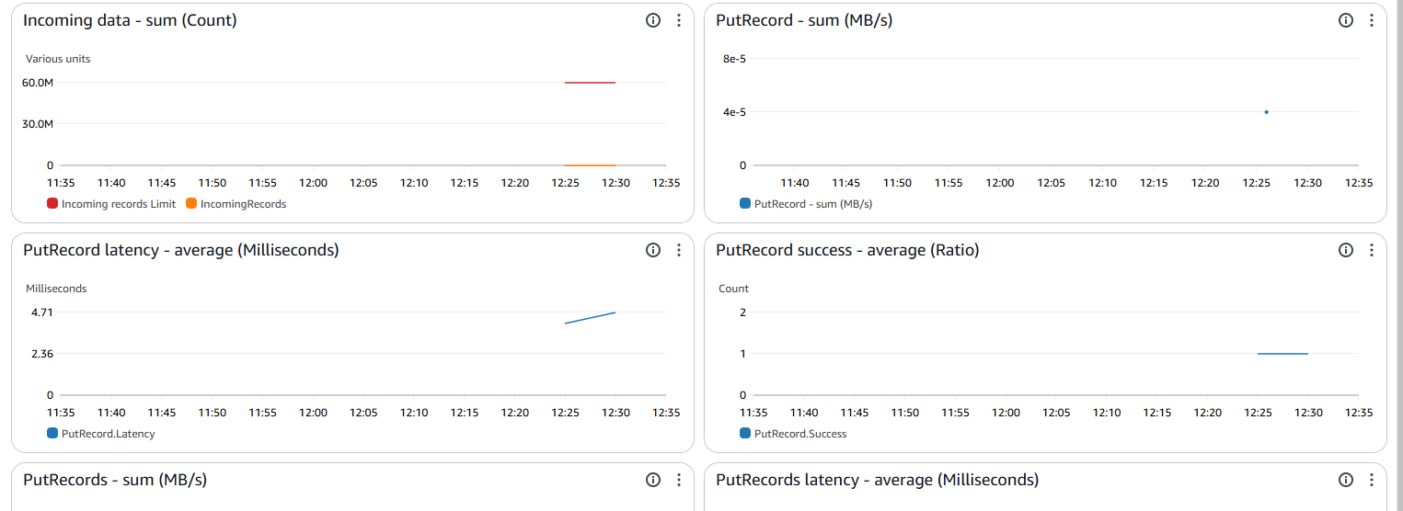

**AWS S3 Storage**

* I have used S3 to store my data
* <https://youtu.be/1iWCPOhtgGE>
* I implemented this feature using the additional student’s AWS portal to use some services which are restricted for the personal learners lab.
* Please refer to the video for the demonstration of this service.

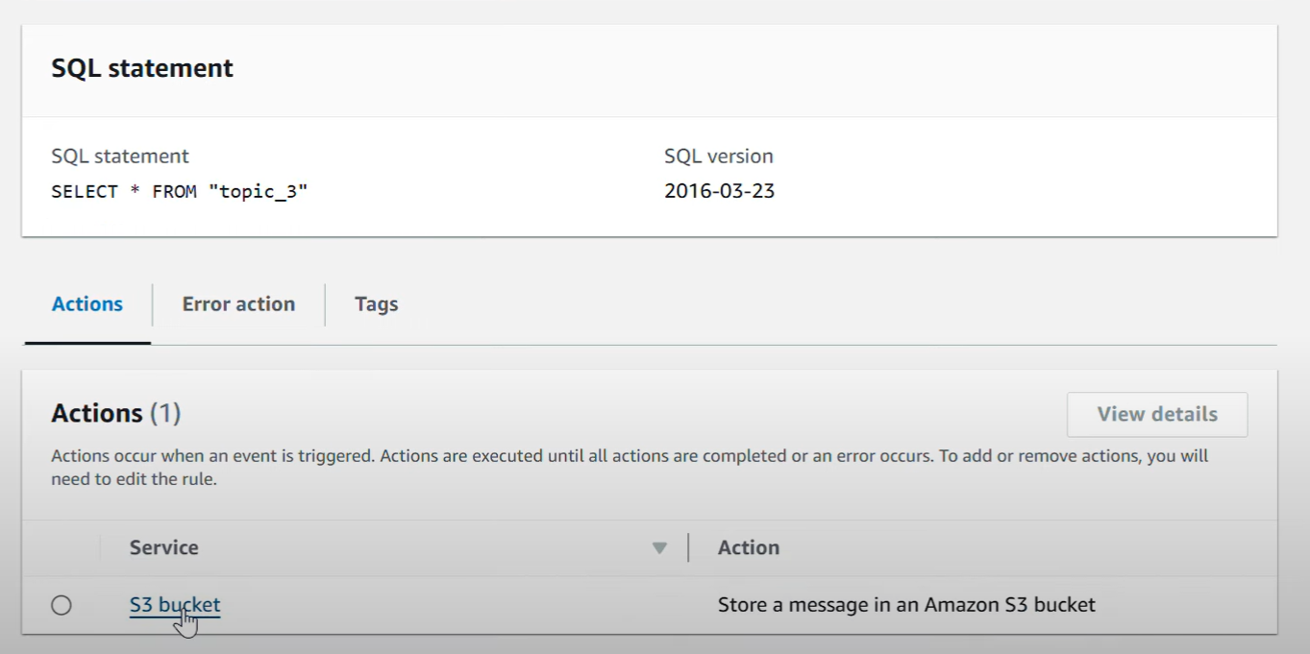

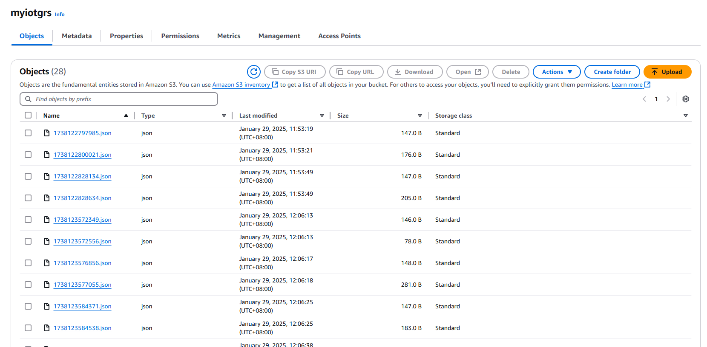

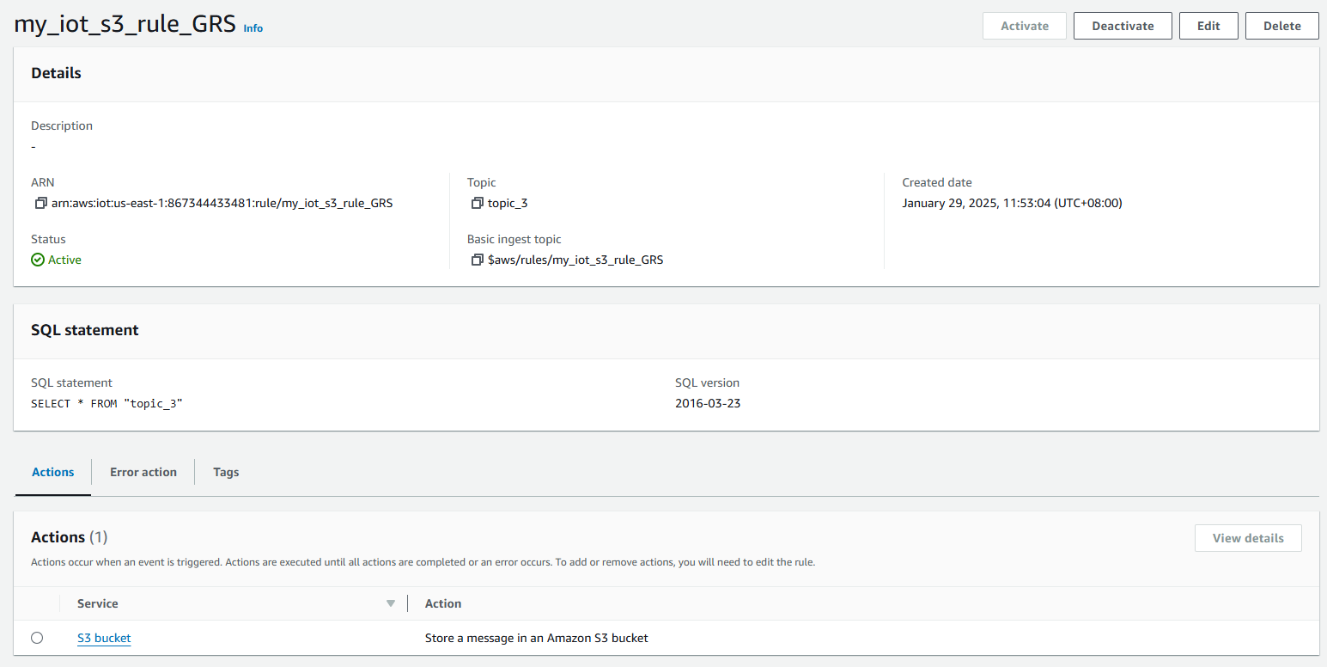



**AWS SNS (sms messaging)**

* I have used SMS protocol to send my messages to the users along with the email.
* I implemented this feature using the additional student’s AWS portal to use some services which are restricted for the personal learners lab.
* Please refer to the video for the demonstration of this service.
* <https://youtu.be/JvdML8DPWio>

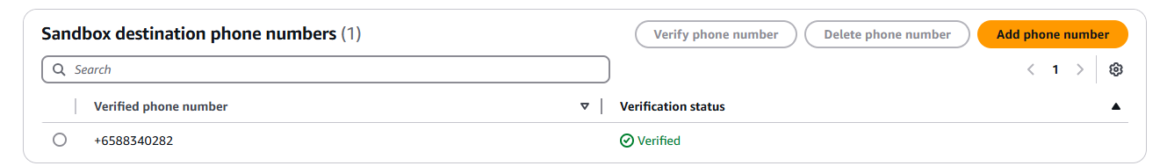



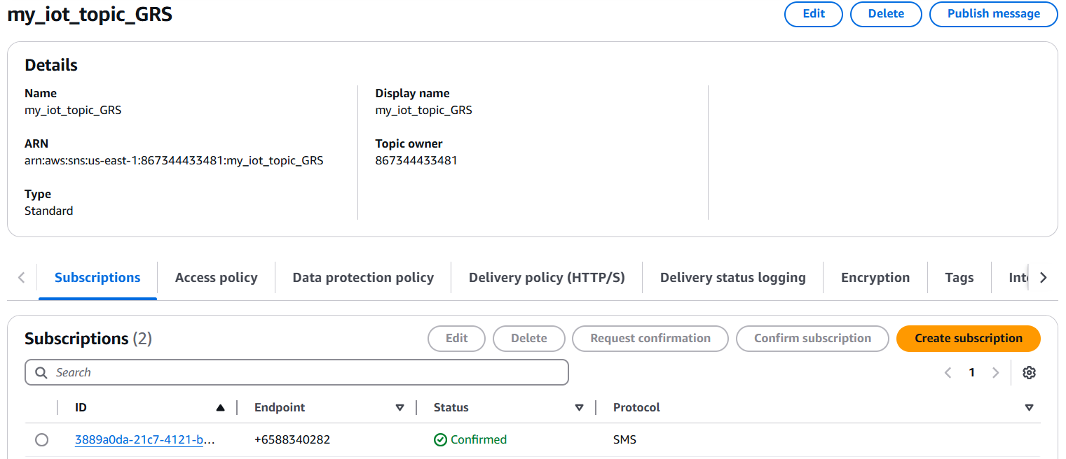

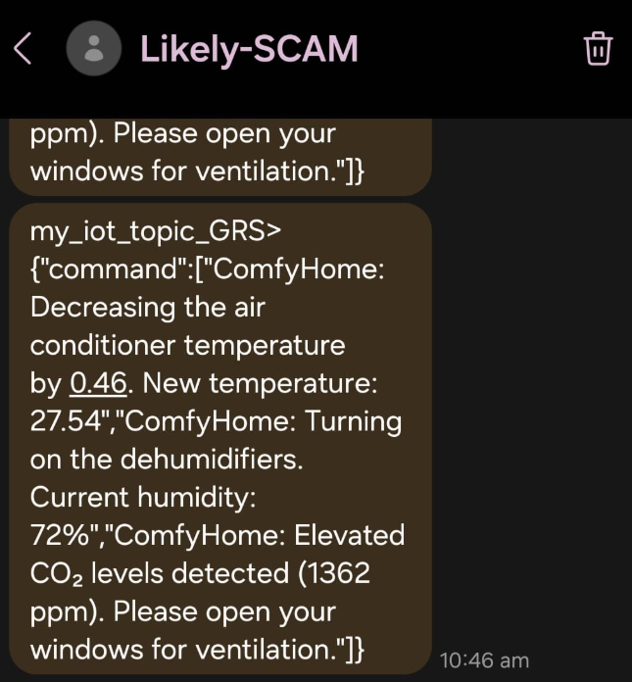 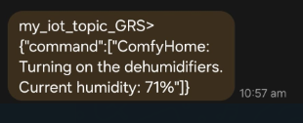

**M5 CORE 2 + ENV III**

* I tried to experiment and try out something new by using the M5 Core device with the ENV III to measure the current temperature of the room.
* I wanted to collect the temperature from this tool and then publish to a mqtt test topic: “topic_2” then create a rule to send all the data from topic_2 to be stored in Dynamo DB.

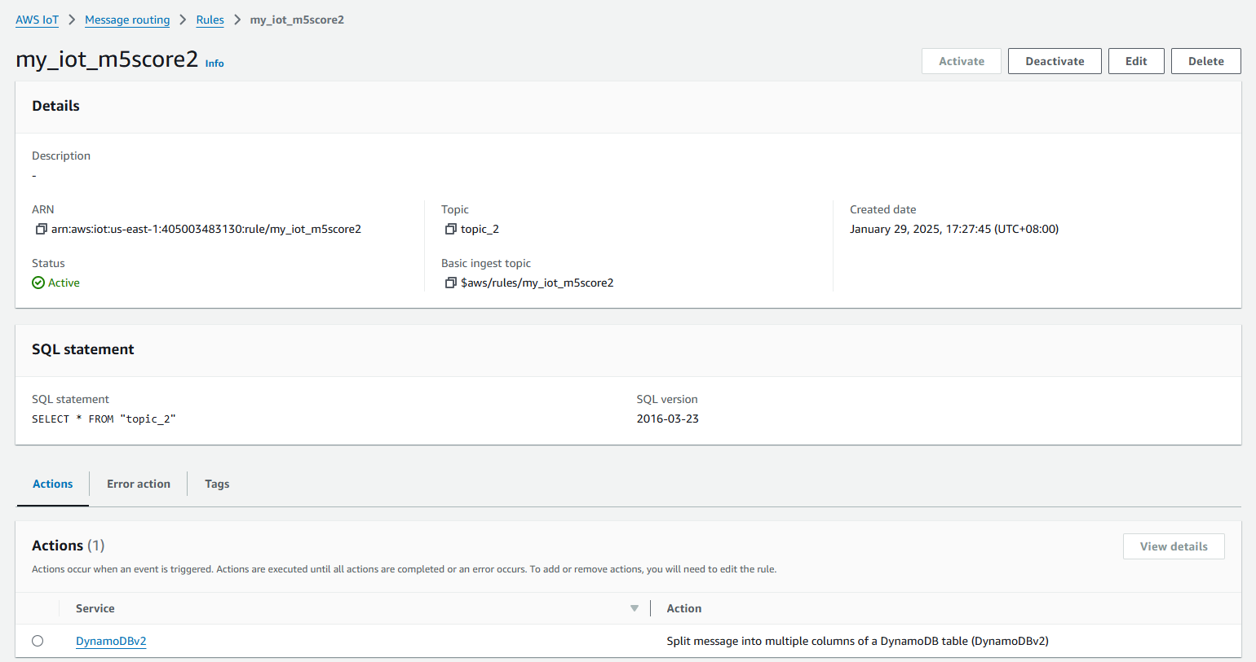 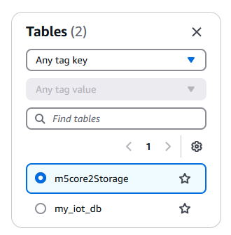

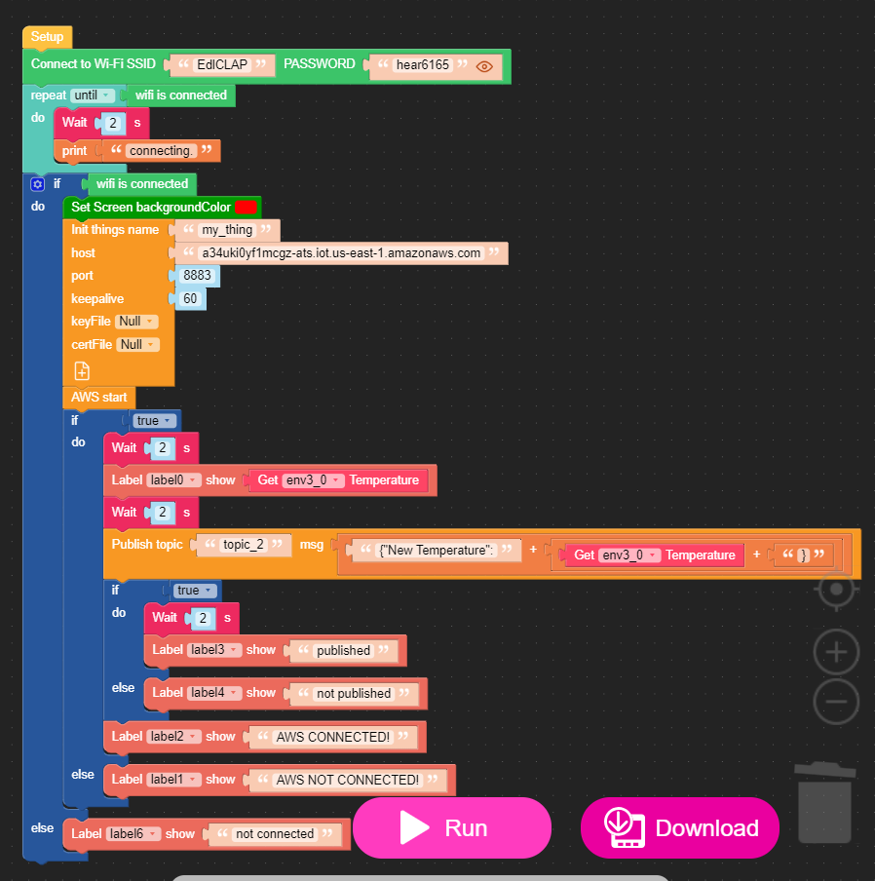

**The end**